Bridgewater Uniting Church.
407-409 Mount Barker Road, Bridgewater SA 5155.
The Oak Centre
Information Regarding our Premises
- Evacuation instructions.
Please refer to map by front door.
- Catastrophic Fire Days.
For the safety of all users, The Oak is unavailable on days with a Catastrophic Bushfire Rating.
- The Oak has a no alcohol consumption policy unless prior permission from Church Council is granted.
- Kitchen - The user will have full access to the kitchen facilities. Including:
- Up to 40 settings (cups, plates, cutlery etc.)
- Fridge
- Stove for heating (some basic pots and pans are available)
- Dishwasher (including cleaning detergent etc.)
- Microwave
- Basic cooking utensils
- Hot water urns / coffee machine (bring your own coffee)
- Tea towels / table cloths
- Toilets:
Unisex toilet facilities are available in the building including a disabled access bathroom.
- Tables:
The Oak facility comes complete with 4 - 1500 x 600 mobile flip tables with comfortable seating for up to 6 people per trestle (3 on either side), and 3 small 1 metre square foldable tables.
- Some trestles are locked away in a store room but may be available upon request and negotiation.
NOTE: the tables are of a light weight construction and people sitting on the tables or excessively loading the tables will be responsible for the cost of repair / replacement of damaged furniture. PLEASE don’t sit on the tables.
Housekeeping Rules for User Groups.
We endeavour to ensure that anyone who uses our facilities enjoys the experience therefore we ask that you observe the following.
- Instructions for heating/cooling
The Oak facility is fitted with two wall-split reverse cycle air conditioners.
It is the users’ responsibility to ensure these are turned off at the end of their assigned time.
- Returning seating arrangements to original state.
It is a requirement that the facility be returned to the original furniture arrangement on completion of their assigned time. (Please refer to photos on noticeboard)
- Removal of rubbish.
The facility is supplied with bins (including recycling) - inside kitchen and outside North wall of Oak building. It is the user’s responsibility to clean up and place rubbish in the bins.
- Cleaning instructions.
It is the user’s responsibility to leave the facility in a clean state. The Oak is supplied with a vacuum cleaner and cleaning equipment located in the storage area adjacent to the toilets for this purpose.
- Carpet cleaning surcharge.
A surcharge for cleaning will be charged when the carpet requires extra cleaning.
- Security of the facility.
Locking of doors windows etc at the conclusion of their assigned time is the responsibility of the user.
- Notice boards are provided for your use.
Please ensure nothing is fixed to any other area of the walls or ceiling.
- Use of confetti / rose petals.
The use of confetti is banned. Rose petals are allowed outside only.
- Emergency Contact people.
Garry Burchell on 0423 464 266 or Julie Burchell on 0403 680 190.
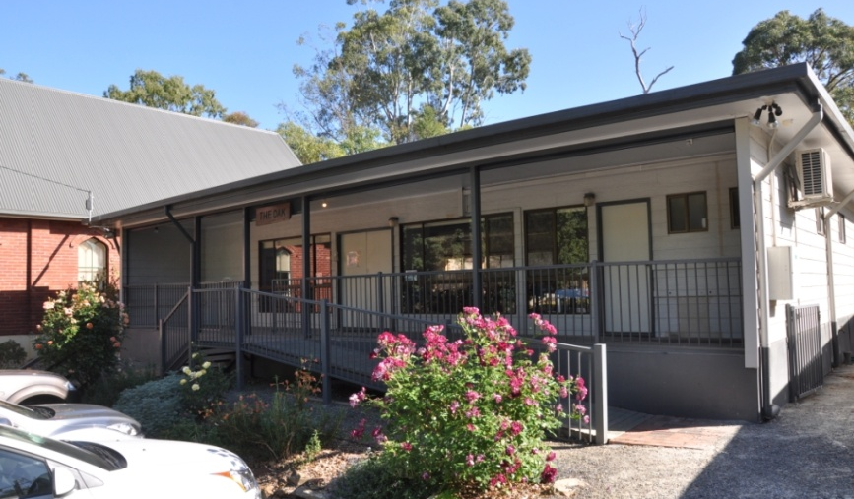
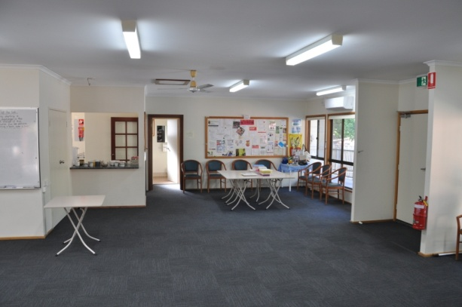 | 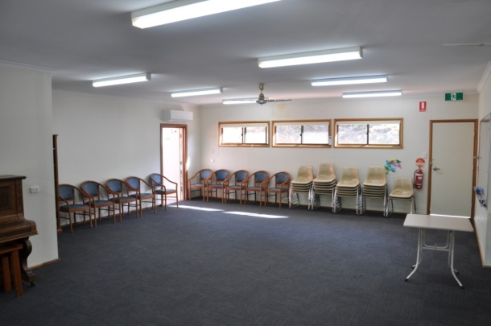
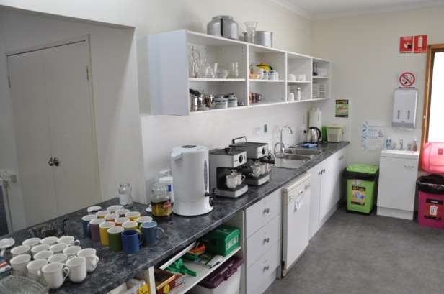 | 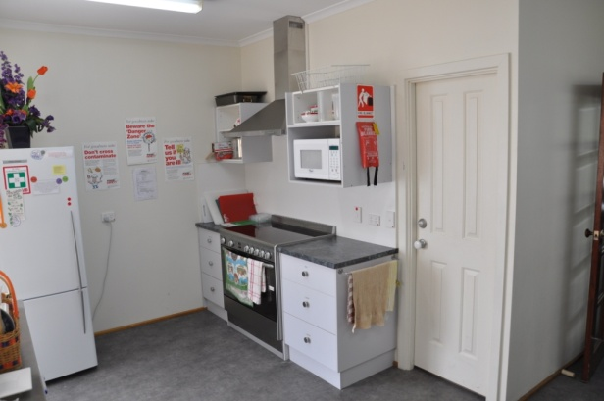

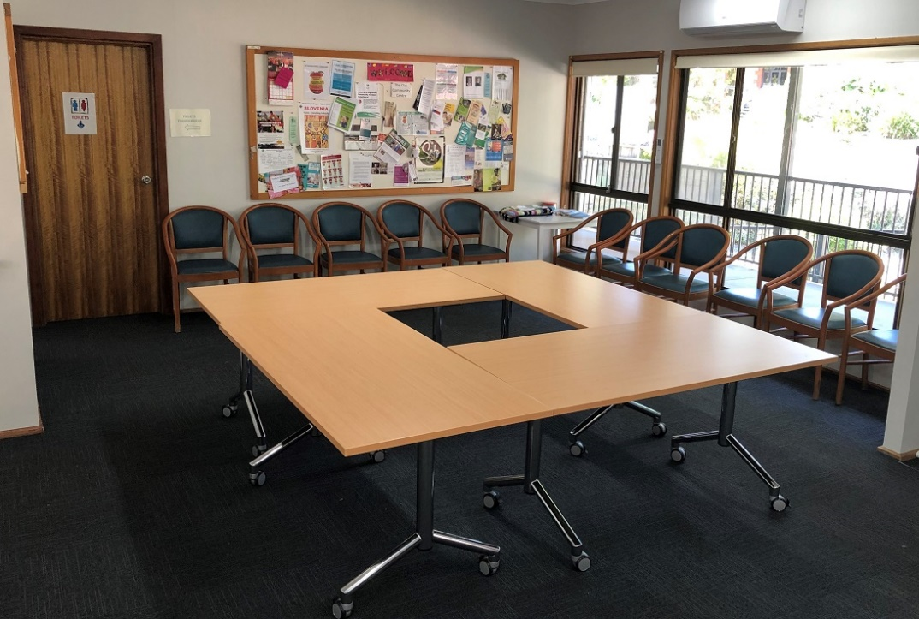
The 4 mobile large tables
